**Lab 2 Report**

***g14_longest_row.vhd***

**Top-level I/O**

**Inputs Outputs**

ASP_r_0 ... ASP_r_7 – ASP_arrays ASP_lrow : 2 bit std_logic_vector

ASP_dr – 7 bit vector

ASP_empty – 7 bit vector

NM – bit

**NB: the ASP_array data type is a 4 by 3 array of std_logic_vector**

**Description of Circuit**

This circuit takes in 8 registers of the type ASP_array, which contain the current state of the filled positions on the connect-4 board. The 7 bit vector ASP_dr reflects the states of the registers as to whether they are full or not full at present. The 7 bit vector ASP_empty reflects the states of the registers as to whether they are empty or not at present. NM is an enable bit.

The circuit evaluates the non-empty and non-full registers, searching for the register which contains the longest row of filled cells. Once all the registers have been parsed, the output ASP_lrow returns a 2 bit vector containing the ID of the register with the longest row.

Flow summary and timing analyzer summary could not be completed on this circuit due to the specified inputs and outputs requiring 212 pins, while the device which the circuit was designed for has only 189 I/O pins. Thus, Quartus II could not run the flow analysis necessary to generate these reports. However, it showed that 258 logic elements were required for the circuit.

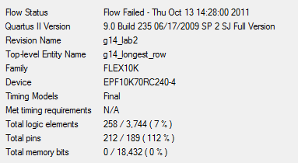

**Testing**

The circuit was tested by creating sample situations by assigning the register values arbitrary numbers and then adjusting ASP_dr and ASP_empty to correspond to the register values. This was done with various setups of arbitrary register values. As shown in the case included, registers 1, 2, 6, and 7 are empty, register 4 is full, and the longest register counted is register 3. The circuit operates correctly, as “001” is returned for ASP_lrow, indicating that register 3 is indeed the longest row.

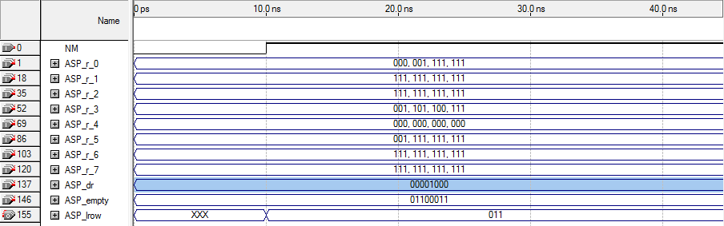

***g14_row_config.vhd***

**Top-level I/O**

**Inputs Outputs**

ASP_r_i – type ASP_array horiz -bit

ASP_c_i – type ASP_array vetic -bit

r_l_diag – bit

l_r_diag – bit

**Description of Circuit**

This circuit takes in two registers (ASP_r_i and ASP_c_i) of type ASP_array, again 4x3 std_logic_vector arrays, which represent the row and column registers for the connect-4 board. The circuit then checks the first two positions of each register (0 and 1) to search for filled cells in horizontal, vertical, and both diagonal configurations. If a configuration is found, its corresponding output becomes true.

Flow analysis was successful for this circuit and showed that 13 logic elements and 28 I/O pins were required for the implementation of this circuit. Timing analyzer showed that the worst-case propogation delay of the circuit was 34.3 ns.  
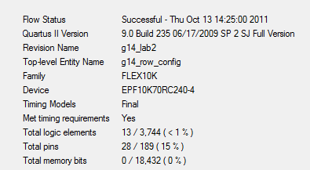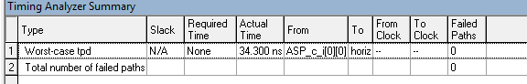

**Testing**

The circuit was tested by applying random values to the register locations at ASP_r_i and ASP_c_i at indices 0 and 1, as they were the only ones checked by the circuit. Each possible output case was identified and is discussed as follows.

1. Horizontal is found when ASP_r_i[1] = “111”
2. Horizontal is found when r[0] = r[1] and c[0] + 1 = c[1]
3. Vertical is found when r[0] + 1 = r[1] and c[0] = c[1]
4. L_R_diag is found when r[0] + 1 = r[1] and c[0] = c[1] + 1
5. R_L_diag is found when r[0] + 1 = r[1] and c[0] + 1 = c[1]



